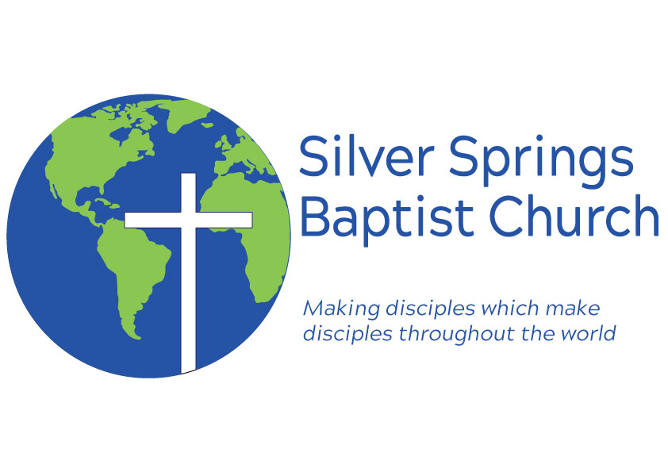
To Our Church Family

First off I want to communicate our love for you and hope that each of you are well. In the recent days President Trump has extended the social distancing guidelines through the month of April. After meeting with the church council we feel it is best to continue to suspend in person services and activities. We will continue to hold church services online through our Facebook page and they will be posted on our website www.ssbcmiss.org.

This decision does affect some events on our calendar. We had a baby shower for Cody and Charlsa Waller on April 5th which will have to be postponed. Continue to pray for Cody and Charlsa as Baby Aiden is due at the beginning of May.

The next event this effects is our Easter Egg Hunt. We will not be able to have our Easter Egg Hunt this year however we are working to bring eggs to each of our children so please make sure that we have each of our kids addresses by sending your address to us.

The next event this effects is Easter. We will not be able meet in person for Easter Sunday. Bro. Dean and I are working on Easter services. You will be seeing some more posts from me on our Facebook page about Easter soon.

The next event this effects is Homecoming. Homecoming will be canceled for this year. This is unfortunate but we will have a reason to make next year’s homecoming even more special.

The last event for right now that has been postponed is revival. We are planning on having a revival at some point but the beginning of May is not the time. Once this passes we will work to put it on the calendar again and communicate those dates to you.

I have been encouraged by many of you who have continued to support the church financially during this time. I want to share with you that you can give online or mailing your gift to the church or to Kendra Fortenberry.

I am continuing to pray for you and if I can do anything for you during this time let me know.

Continue to seek the Lord during this time,
Bro. Brock

